

IOT WORKSHOP

Day-2

ELECTRONIC COMMUNICATION & ENGINEERING[ECE]

Team members:-

E. Hima Bindu(24KE5A0406)

Ch. Alekhya Gayathri(24KE5A0404)

D. Thrisha(24KE5A0405)

K. Priya Darshini(23KE1A0450)

G. Siva Parvathi(23KE1A0431)

FROM:ECE-A…….

Team Name:

SMART CREATORS

**ACTIVITY - 6**

## .Reading gas sensors values displaying the serial monitor.

* Components:-

*ESP32

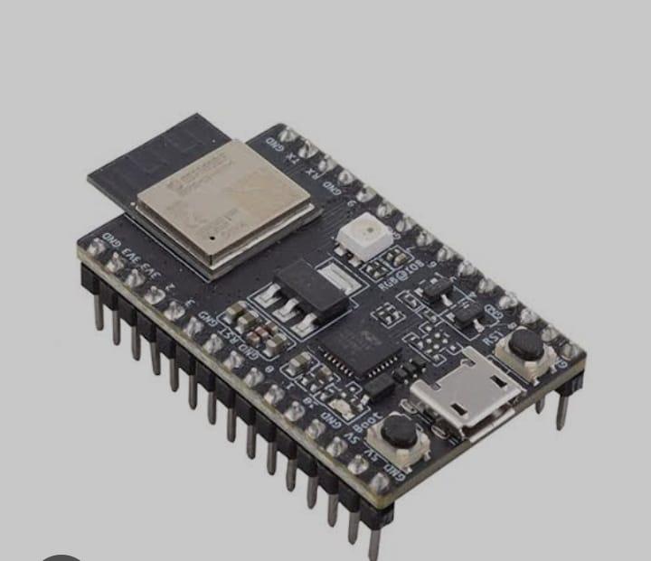

*GAS SENSOR

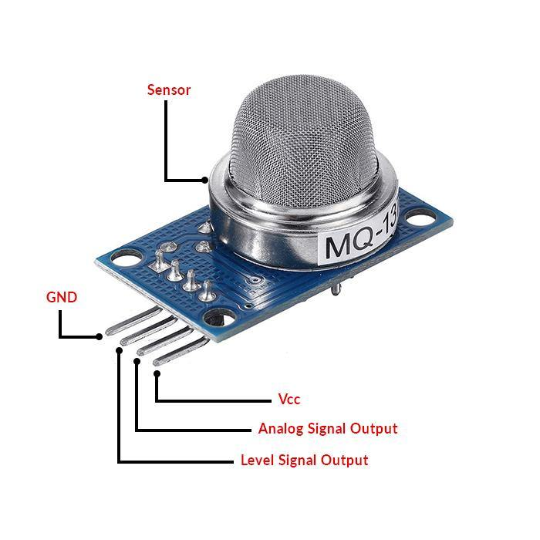

*FEMALE TO FEMALE CONNECTORS

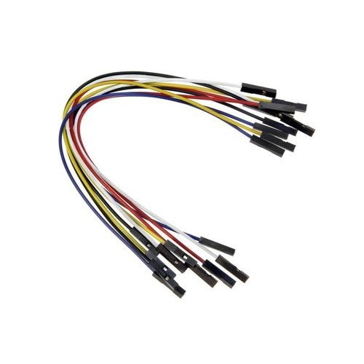

*USB CABLE

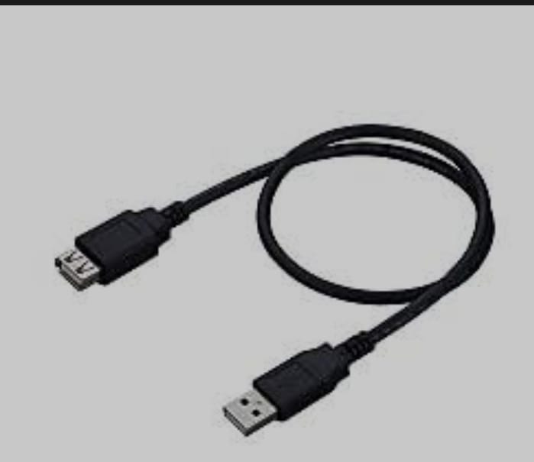

* Connections:-
* **Connect A0 pin of the gas sensor to the ESP32 34th pin.**
* **Connect Ground pin of the gas sensor to the ESP32 ground pin.**
* **Connect VCC of the gas sensor to the ESP32 to VIN(v5).**
* PROGRAM:-

Int gas = 34;

Void setup() {

pinMode (gas , INPUT) ;

Serial . begin (9600);

}

Void loop () {

Int g = analogRead (gas) ;

Serial . println (g) ;

}

Output:

* After writing the code we have to compile code.
* After that connect the USB cable laptop to ESP32. We have to dump the code on the ESP32.
* Next connect all connections.
* After that we have to connect again USB cable to the laptop to ESP32.
* Then observe the output on serial monitor the initial values of the gas sensor will be high when the gas sensor not detect any harmful gases output is shown below

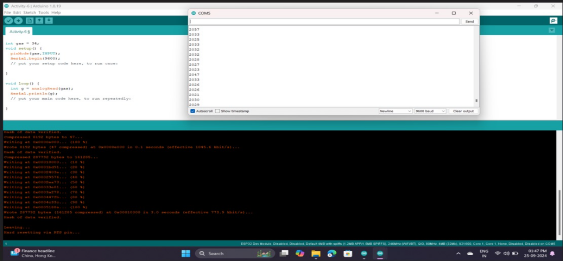

* Then observe the output on serial monitor.the final values are low, when the gas sensor detects some harmful gasses the output is shown below.

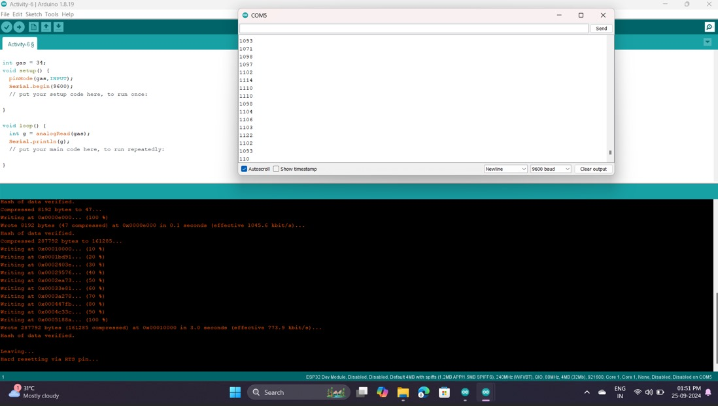

**ACTIVITY – 7**

## Q.Checking the conditions for gas sensors.

Components:-

*ESP32



*USB CABLE



*GAS SENSOR



*FEMALE TO FEMALE WIRES



Connections:-

* **Connect pin A0 of the gas sensor to the ESP32 34th pin.**
* **Connect Ground pin of the gas sensor to the ESP32 ground pin.**
* **Connect VCC of the gas sensor to the ESP32 to VIN(v5).**

PROGRAM:-

int gas = 34;

int threshold = 25;

void setup() {

pinMode(gas,INPUT);

Serial.begin(9600);

}

void loop() {

int g = analogRead(gas);

Serial.println(g);

if(g>threshold){

Serial.println("harmful gas detected");

}

else{

Serial.println("no gas detected");

}

}

Output:

* After writing the code we have to compile code.
* After that connect the USB cable laptop to ESP32. We have to dump the code on the ESP32.
* Next connect all connections.
* After that we have to connect again USB cable to the laptop to ESP32.
* Then observe the output on serial monitor when the gas sensor detects no harmful gas then prints output on serial monitor with condition output is shown below

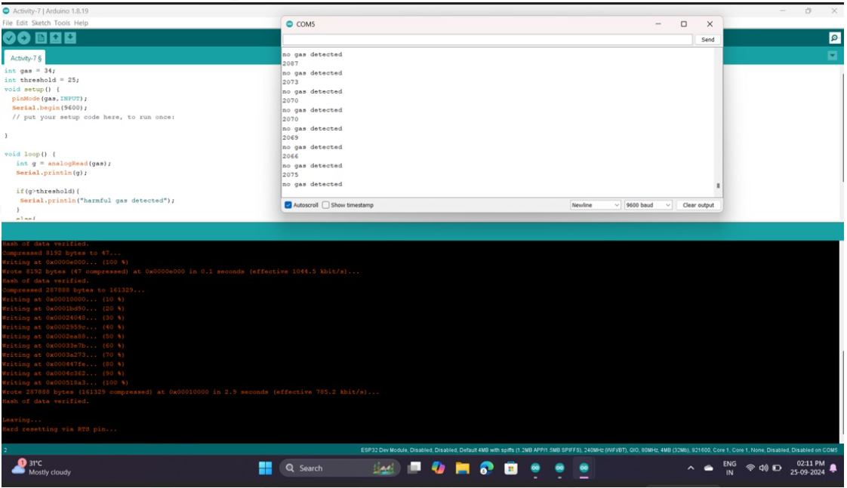

* Then observe the output on serial monitor when the gas sensor detects harmful gases then prints the output on serial monitor with condition output is shown below

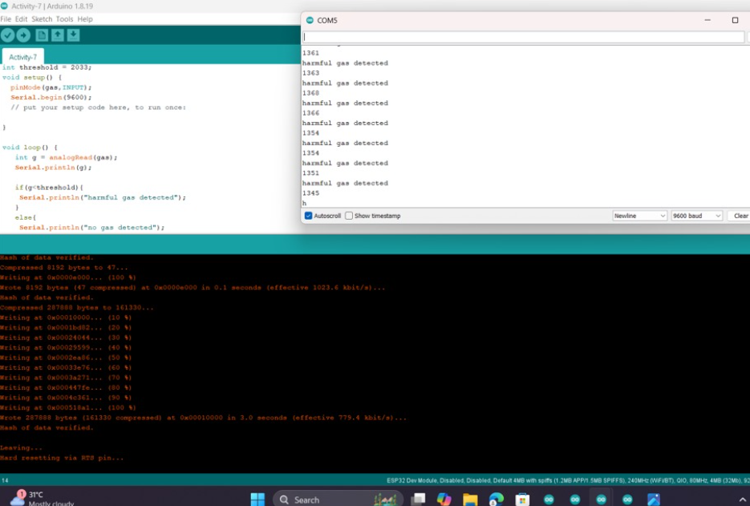

**ACTIVITY – 8**

**Q. Reading IR sensor values and displaying in serial monitor**

Components:-

*ESP32



*USB CABLE



*FEMALE TO FEMALE WIRES



*IR SENSOR

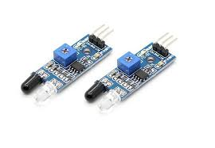

Connections:-

* **Connect the Do pins of the ir sensor to the ESP32 12th pin.**
* **Connect the Ground pin of the ir sensor to the ESP32 ground pin.**
* **Connect VCC pin of the ir sensor to the ESP32 to vin(v5)**

PROGRAM:-

Int ir =12 ;

Void setup () {

pinMode(ir,INPUT);

Serial . begin(9600);

}

Void loop (){

Int g = digital Read (ir) ;



Serial .print ln(g);



}

Output:

* After writing the code we have to compile code.
* After that connect the USB cable laptop to ESP32. We have to dump the code on the ESP32.
* Next connect all connections.
* After that we have to connect again USB cable to the laptop to ESP32.
* Then observe the output on serial monitor when the ir sensor detects no object then it shows the output is 1 output is shown below

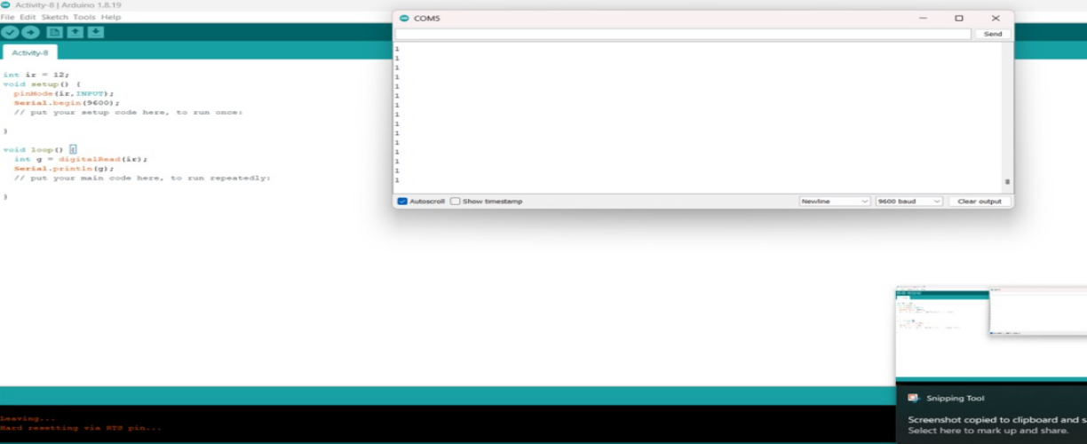

* Then observe the output on serial monitor when the ir sensor detects object then it shows the output is 0 output is shown below

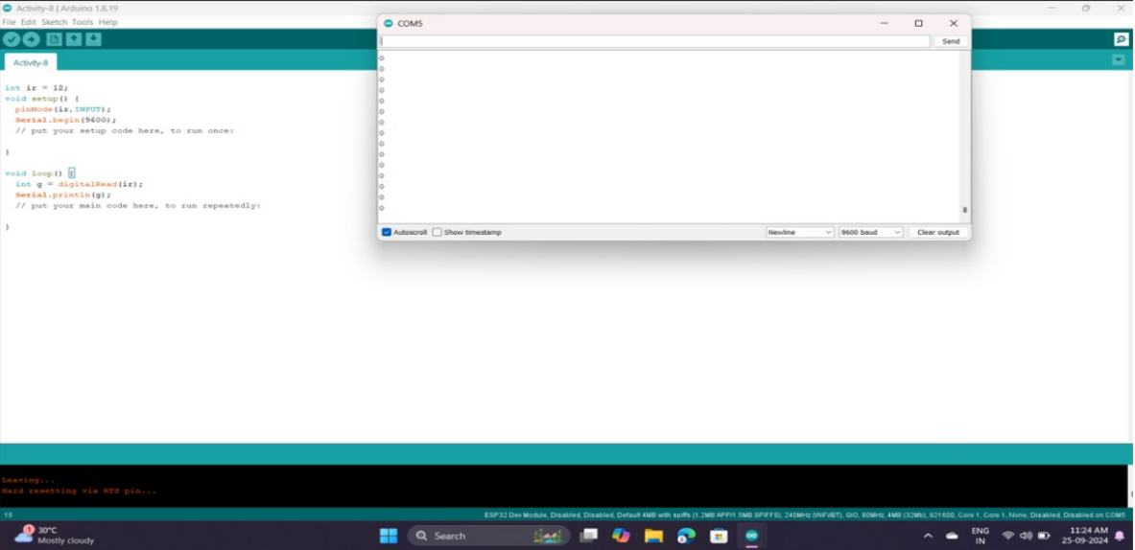

**ACTIVITY – 9**

Q.Check the conditions for IR sensor.

Components:-

*ESP32



*USB CABLE



*FEMALE TO FEMALE WIRES



*IR SENSOR



Connections:-

* **Connect the Do pins of the ir sensor to the ESP32 12th pin.**
* **Connect the Ground pin of the ir sensor to the ESP32 ground pin.**
* **Connect VCC pin of the ir sensor to the ESP32 to VIN(v5)**

PROGRAM:-

int ir = 12;

void setup() {

pinMode(ir,INPUT);

Serial.begin(9600);

// put your setup code here, to run once:

}

void loop() {

int a = digitalRead(ir);

Serial.println(a);

if(a==0){

Serial.println("Object detected");

}

else{

Serial.println("No Object Detected");

}

}

Output:

* After writing the code we have to compile code.
* After that connect the USB cable laptop to ESP32. We have to dump the code on the ESP32.
* Next connect all connections.
* After that we have to connect again USB cable to the laptop to ESP32.
* Then observe the output on serial monitor when the ir sensor detects no object then it shows the output is 1 and prints the statement no object detected output is shown below

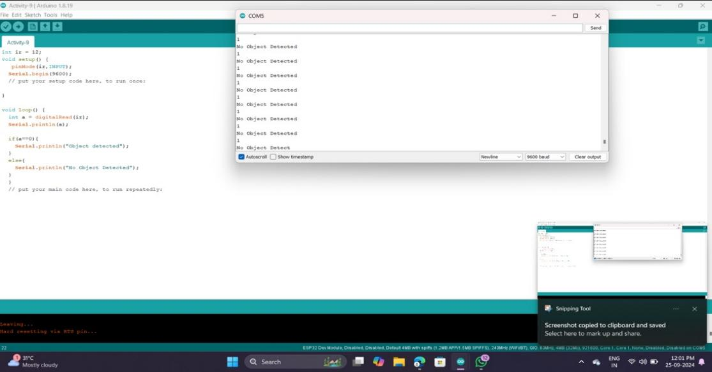

* Then observe the output on serial monitor when the ir sensor detects object then it shows the output is 0 and prints the statement object detected output is shown below

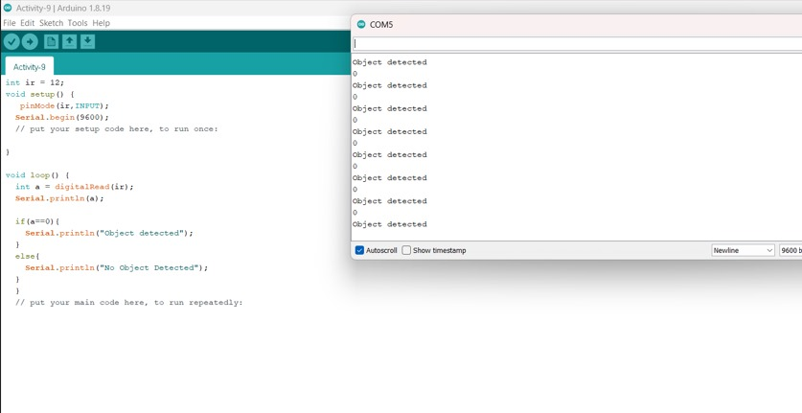

**ACTIVITY – 10**

## Q.Reading soil moisture sensor values and displayed in serial monitor.

Components:-

*ESP32



*USB CABLE



*FISCHER SENSOR

*SOIL MOISTUR SENSOR

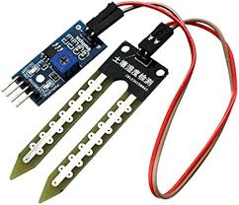

*FEMALE TO FEMALE WIRES



Connections:-

* **Connect the Ao pins of the fish sensor to the ESP32 34th pin.**
* **Connect the both soil moisture sensor and fish sensor.**
* **Connect the Ground pin of the soil moisture sensor to the ESP32 ground pin.**
* **Connect the VCC pin of the soil moisture sensor to the ESP32 to VIN(v5).**

PROGRAM:-

int soil = 34;

void setup() {

pinMode(soil,INPUT);

Serial.begin(9600);

// put your setup code here, to run once:

}

void loop() {

int a = analogRead(soil);

Serial.println(a);

// put your main code here, to run repeatedly:

}

Output:

* After writing the code we have to compile code.
* After that connect the USB cable laptop to ESP32. We have to dump the code on the ESP32.
* Next connect all connections.
* After that we have to connect again USB cable to the laptop to ESP32.
* Then observe the output on serial monitor when the soil moisture sensor detects when the soil content is not have moisture then it shows the output values on serial monitor is shown below

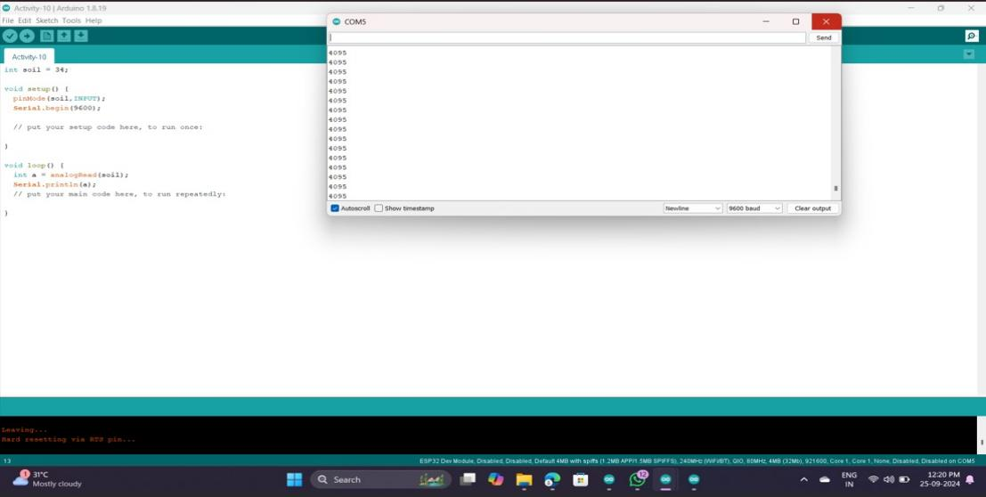

* Then observe the output on serial monitor when the soil moisture sensor detects when the soil content have moisture then it shows the output values on serial monitor is shown below

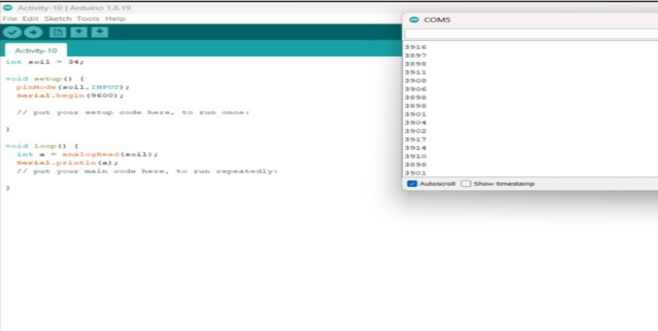

**ACTIVITY – 11**

Q.Checking the conditions for gas sensors.

Components:-

*ESP32



*USB CABLE



*FISH SENSOR

*SOIL MOISTUR SENSOR



*FEMALE TO FEMALE WIRES



Connections:-

* **Connect the Ao pins of the fish sensor to the ESP32 34th pin.**
* **Connect the both soil moisture sensor and fish sensor.**
* **Connect the Ground pin of the soil moisture sensor to the ESP32 ground pin.**
* **Connect the VCC pin of the soil moisture sensor to the ESP32 to vin(v5).**

PROGRAM:-

int soil = 34;

int threshold = 4095;

void setup() {

pinMode(soil,INPUT);

Serial.begin(9600);

// put your setup code here, to run once:

}

void loop() {

int a = analogRead(soil);

Serial.println(a);

if(a<threshold){

Serial.println("moisture Detected");

}

else{

Serial.println("No Moisture Detected");

}

}

Output:

* After writing the code we have to compile code.
* After that connect the USB cable laptop to ESP32. We have to dump the code on the ESP32.
* Next connect all connections.
* After that we have to connect again USB cable to the laptop to ESP32.
* Then observe the output on serial monitor when the soil moisture sensor detects when the soil content is not have moisture then it prints with statement it shows the output values on serial monitor is shown below

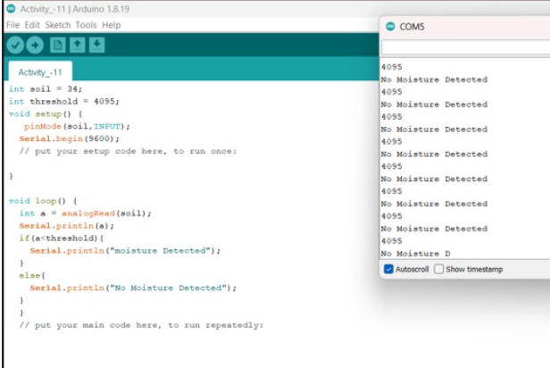

* Then observe the output on serial monitor when the soil moisture sensor detects when the soil content have moisture then it prints with statement it shows the output values on serial monitor is shown below

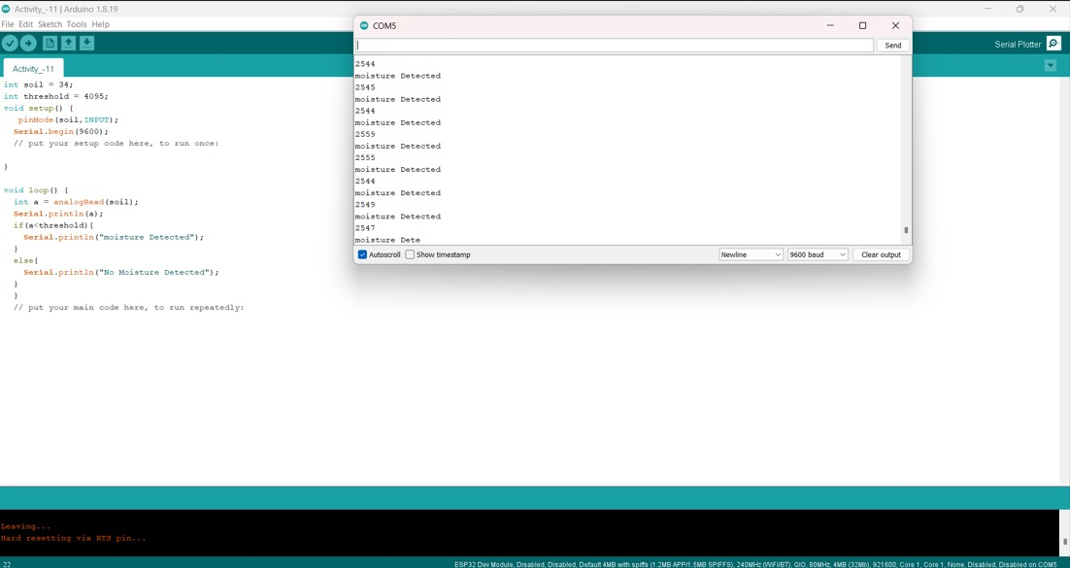

**ACTIVITY – 12**

Q.PRINT THE VALUES OF SOIL MOISTURE SENSOR.

Components:-

*ESP32



*USB CABLE



*ULTRASONIC SENSOR

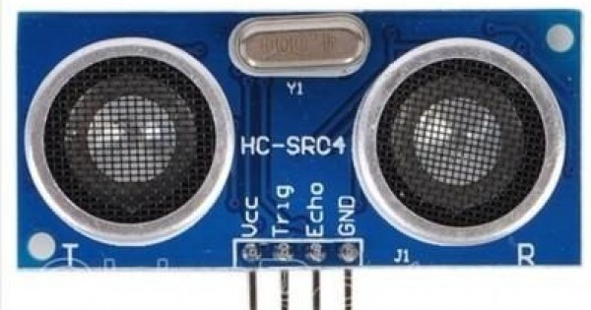

*FEMALE TO FEMALE WIRES



PROGRAM:-

int trig = 14;

int echo = 4;

void setup() {

pinMode(trig,OUTPUT);

pinMode(echo,INPUT);

Serial.begin(9600);

// put your setup code here, to run once:

}

void loop() {

digitalWrite(trig,0);

delayMicroseconds(2);

digitalWrite(trig,1);

delayMicroseconds(10);

digitalWrite(trig,0);

float duration =pulseIn(echo,1);

duration=duration/2;

float distance=(0.034)*duration;

Serial.println(distance);

}

Connections:-

*Connect the trig pin to 14th pin of ESP32

* Connect the ECO pin to the 4 th pin of ESP32

* Connect ground to ground

* Connect Vcc to the Power terminal.

Output:

* After writing the code we have to compile code.
* After that connect the usb cable laptop to ESP32. We have to dump the code on the ESP32.
* Next connect all connections.
* After that we have to connect again usb cable to the laptop to ESP32.
* Then observe the output on serial monitor when the ultra sonic sensor detects when the object is far to the sensor then the output values on serial monitor is shown below

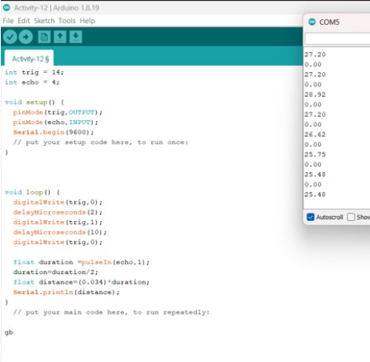

* Then observe the output on serial monitor when the ultra sonic sensor detects when the object is near to the sensor then the output values on serial monitor is shown below



